Assignment 2

QUESTION 2 (Find relationships)

**- Go to the web page for Federal Reserve data at: http://research.stlouisfed.org/**

**- Download exchange rate data for 6 countries of your choice versus the US dollar. Summarize this data and plot the series. Provide a brief description.**

Below is a section of the exchange rate data for 6 countries

head(fx)

DATE US Egypt Greece Hong.Kong India Italy Netherlands

1 1/1/50 1 0.3481407 0.04399120 5.71 4.7629 0.3226230 1.723911

2 1/1/51 1 0.3482420 0.04399118 5.71 4.7629 0.3222620 1.724365

3 1/1/52 1 0.3482420 0.04399118 5.71 4.7629 0.3222105 1.724819

4 1/1/53 1 0.3481407 0.07621422 5.71 4.7629 0.3222105 1.724365

5 1/1/54 1 0.3481407 0.08804109 5.71 4.7629 0.3222105 1.724365

6 1/1/55 1 0 .3482420 0.08804109 5.71 4.7639 0.3222105 1.724365

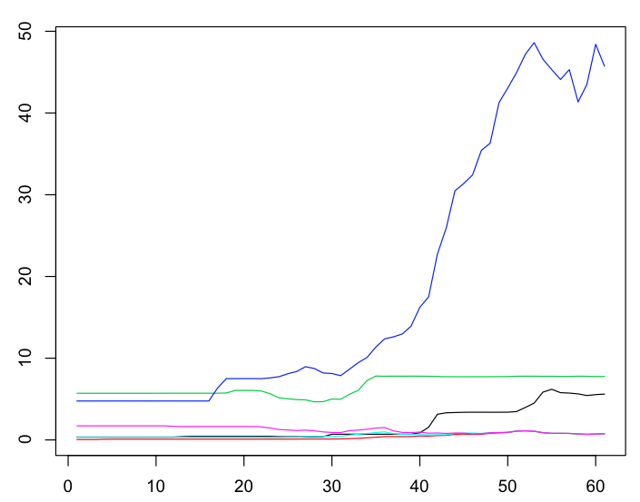

* **Present the correlation table of exchange rates.**

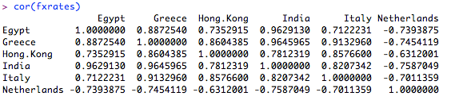

* **Present the correlation table of changes in exchange rates.**

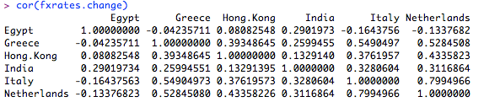

* **Pick your favorite pair of exchange rates and say whether the correlation of exchange rate changes in statistically significant or not. How would you establish this?**

**How do we establish this?**

* **Regress one series of exchange rate changes on another, and describe the output (R-square, t-statistics, f-statistic, etc.) Is there any economic conclusion that you can infer from the regression?**

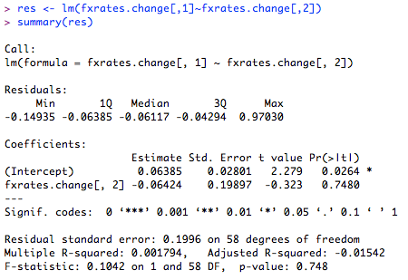

The p-value of 0.7480 indicates that 74.8% of the time the changes in currency value of Greece is correlated to the change in currency value of Egypt. Is this correct?

* **Using the data series you have, can you build a model that uses lagged values of changes in exchange rates to predict future exchange rate changes with a high level of accuracy? (This requires some experimentation and playing with the data. Ideally program R to run all possible cases.)**

I wasn’t sure how to do this. Do we take the lag values of each currency? The only was I could think of doing this was to run each case manually. Is there a better way to do this?

* **Run a vector autoregression (VAR) on the data of exchange rate changes that you have. What inferences can you make from the results?**

**QUESTION 3: (using a package)**

**1) Install the "quantmod" package in R (http://www.quantmod.com/).**

**2) Use this package to download data on your favorite stock and the**

**S&P500 index.**

1. **Plot the time series of the stock price and index on the same graph.**

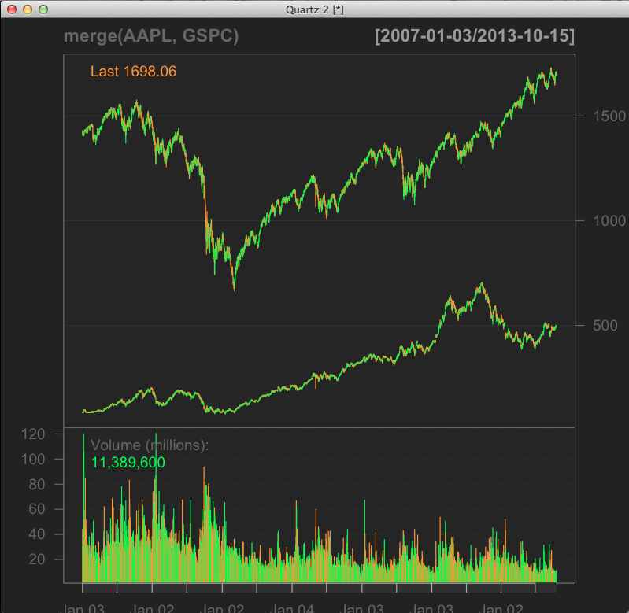

**4) Using the closing price data you have, compute the percentage return on the stock and index from day to day over the entire time series period.**

stocks <- cbind(aapl, gspc)

stocks.ret <- log(stocks[2:n,]/stocks[1:(n-1),])

> head(stocks.ret)

aapl gspc

[1,] 0.021965570 0.0012275394

[2,] -0.007107179 -0.0061031642

[3,] 0.004823936 0.0022178536

[4,] 0.079857601 -0.0005168233

[5,] 0.046762330 0.0019384787

[6,] -0.012479496 0.0063198821

**5) Plot a scatter plot of the stock return and index return. What can you say about the correlation of returns from visually examining this graph?**

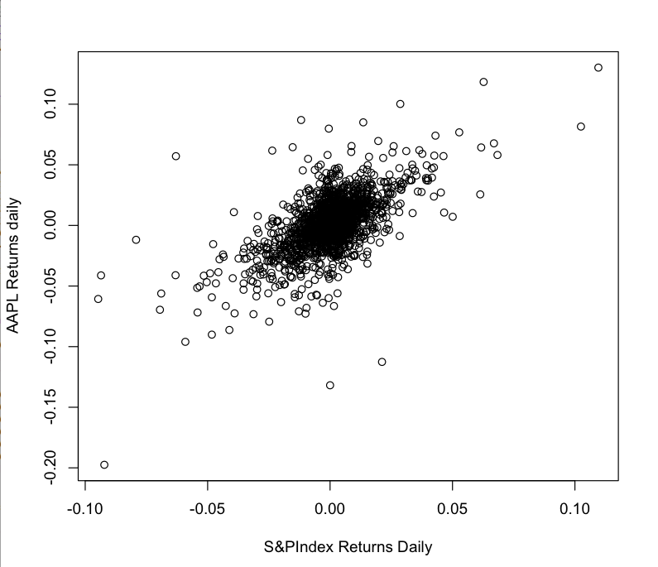

The scatterplot shows that there is a heavy correlation between AAPL stocks and the S&P500 Index

**6) Regress the stock return on the index return and report the results? What is the meaning of the coefficients in this regression?**

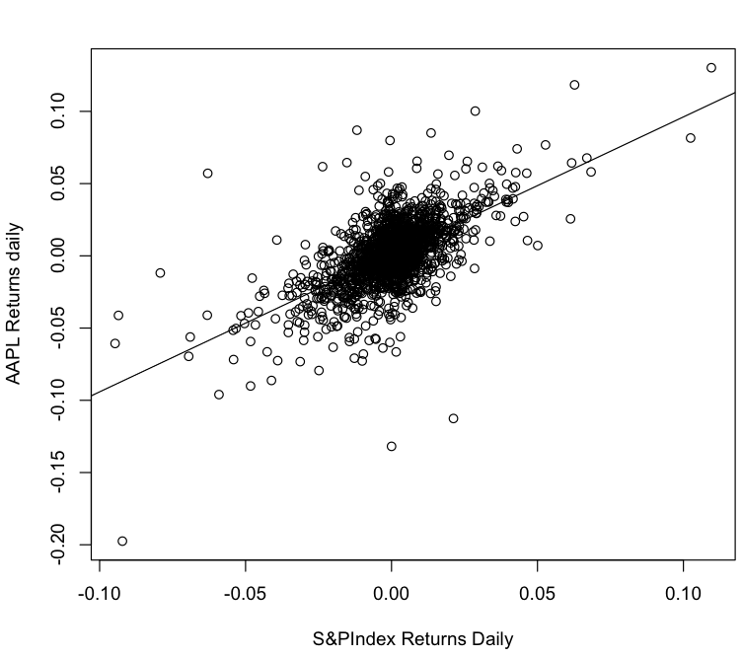

Call:

lm(formula = stocks.ret[, 1] ~ stocks.ret[, 2])

Coefficients:

(Intercept) stocks.ret[, 2]

0.0009595 0.9518297

The slope of the value is close to 1. This indicates that the β value is close to 1 and the movement of the AAPL stock is very much correlated to the movement of the S&P500 Index.

**7) Is the stock more or less risky than the index? How would you determine this?**

mean(stocks.ret[,1])

[1] 0.001060516

> var(stocks.ret[,1])

[1] 0.0005307758

> mean(stocks.ret[,2])

[1] 0.0001061047

> var(stocks.ret[,2])

[1] 0.0002241071

We calculated the mean and variance of the both AAPL and GSPC’s stock returns and found that the mean was around the same, but the variance was the much wider for AAPL than the index. This indicates that AAPL is more volatile that the index and is therefore riskier among the two.

**- Does the stock return lead or lag the index return?**

aapl gspc gspc_lag

[1,] 0.021965570 0.0012275394 0.0000000000

[2,] -0.007107179 -0.0061031642 0.0012275394

[3,] 0.004823936 0.0022178536 -0.0061031642

[4,] 0.079857601 -0.0005168233 0.0022178536

[5,] 0.046762330 0.0019384787 -0.0005168233

[6,] -0.012479496 0.0063198821 0.0019384787

res = lm(stocks.ret[,1] ~ stocks.ret[,2] + stocks.ret[,3])

summary(res)

lm(formula = stocks.ret.rag[, 1] ~ stocks.ret.rag[, 2] + stocks.ret.rag[,

3])

Residuals:

Min 1Q Median 3Q Max

-0.133390 -0.008907 -0.000170 0.008752 0.117697

Coefficients:

Estimate Std. Error t value Pr(>|t|)

(Intercept) 0.0009544 0.0004381 2.179 0.0295 *

stocks.ret.rag[, 2] 0.9567642 0.0294766 32.458 <2e-16 ***

stocks.ret.rag[, 3] 0.0417314 0.0294786 1.416 0.1571

---

Signif. codes: 0 ‘***’ 0.001 ‘**’ 0.01 ‘*’ 0.05 ‘.’ 0.1 ‘ ’ 1

Residual standard error: 0.0181 on 1705 degrees of freedom

Multiple R-squared: 0.3833, Adjusted R-squared: 0.3825

F-statistic: 529.8 on 2 and 1705 DF, p-value: < 2.2e-16

Brian - Can you explain the significance of the P value and T value here? I am entirely sure what to write here?

* **What is the autocorrelation of the stock return series and the index return series? Which is greater? What can you say economically from observing the autocorrelations?**

**Please complete this answer also**